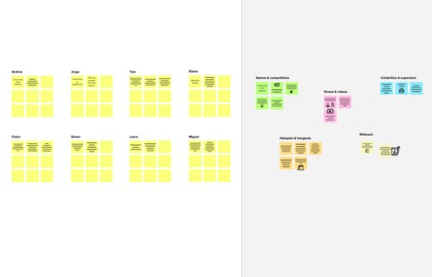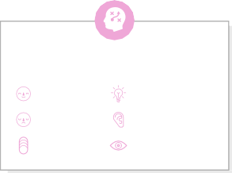

# Brainstorm

## Before you collaborate

#### A little bit of preparation goes a long way with this session. Here’s what you need to do to get going.

##### 10 minutes

**1**

## Define your problem statement

#### Leakage of harmful gases on industries which may harm human and surroundings.

##### 5 minutes

**2**

## Brainstorm

#### Using Internet Of Things for automated detection of leakage

##### 10 minutes

**3**

## Group ideas

#### Take turns sharing your ideas while clustering similar or related notes as you go. Once all sticky notes have been grouped, give each cluster a sentence-like label. If a cluster is bigger than six sticky notes, try and see if you and break it up into smaller sub-groups.

##### 20 minutes

**4**

## Prioritize

#### Your team should all be on the same page about what's important moving forward. Place your ideas on this grid to determine which ideas are important and which are feasible.

**20 minutes**

## After you collaborate

You can export the mural as an image or pdf to share with members of your company who might find it helpful.

**Quick add-ons**

# & idea prioritization

|  |  |  |  |  |  |  |
| --- | --- | --- | --- | --- | --- | --- |
|  | | | | | | |
|  |  |  |  |  | Installtion of Automated System |  |
| Alerting Fire services |  |  |  | Regular maintenence |  |
| Sending notifications |  | Precaution measures |  | Gas flow monitoring |  |
| Training workers to adopt IOT |  |  | Providing Gas resistant suit to workers |  |  |
|  |  |  |  |  |  |
|  |  |  |  |  |  |

###### Team gathering

**GOKILA KM**

###### GAYATHRI R

**JAYALAKSHMI**

###### HEMALATHA

Define who should participate in the session and send an invite. Share relevant information or pre-work ahead.

Providing

**PROBLEM**

**The leakage of harmful gases from industries.**

**Creating harmful for peoples and environment.**

Automated

Use of

Providing

Using various

Use of

Sending

Making phone call

Regular

Always

Sending

Availing quicker

**A Share the mural**

**Share a view link** to the mural with stakeholders to keep

24/7

gas

internet

alerts on

sensors for detection

notification on

sensor

connected

location to

safety

Use this template in your own brainstorming sessions so your team can unleash their imagination and start shaping concepts even if you're not sitting in the same room.

###### Set the goal

Think about the problem you'll be focusing on solving in the brainstorming session.

###### Learn how to use the facilitation tools

Use the Facilitation Superpowers to run a happy and

monitoring

Monitoring every gas flow system

detecting

of things

leakage

detection

system

to mobiles

detection

Tesing

to cloud

fire service

measures

Providing Necessary sensors at required place

Proper alarming system for leakages

Notification and Calling for leakages

Immediate calling of fire services

them in the loop about the outcomes of the session.

**B Export the mural**

Export a copy of the mural as a PNG or PDF to attach to emails, include in slides, or save in your drive.

**10 minutes** to prepare

**1 hour** to collaborate

**2-8 people** recommended

productive session.

[**Open article**](https://support.mural.co/en/articles/2113740-facilitation-superpowers)

Limiting the gas flow per second in transimiision

Cut off the electicity

Precaution measures for safety

Immediate close of gas supply

A less complicated system

Avoiding manual detection

**Key rules of brainstorming**

To run an smooth and productive session

###### Person 5

|  |  |  |
| --- | --- | --- |
|  |  |  |
|  |  |  |
|  |  |  |

**Person 6**

|  |  |  |
| --- | --- | --- |
|  |  |  |
|  |  |  |
|  |  |  |

###### Person 7

|  |  |  |
| --- | --- | --- |
|  |  |  |
|  |  |  |
|  |  |  |

**Person 8**

|  |  |  |
| --- | --- | --- |
|  |  |  |
|  |  |  |
|  |  |  |

Sensing of

flammable

things near

gas flow

### Keep moving forward

###### Strategy blueprint

Define the components of a new idea or strategy.

###### [Open the template](https://app.mural.co/template/e95f612a-f72a-4772-bc48-545aaa04e0c9/984865a6-0a96-4472-a48d-47639307b3ca)

**Customer experience journey map**

Understand customer needs, motivations, and

Stay in topic. Defer judgment.

Encourage wild ideas. Listen to others.

### Importance

If each of these

obstacles for an experience.

###### [Open the template](https://app.mural.co/template/b7114010-3a67-4d63-a51d-6f2cedc9633f/c1b465ab-57af-4624-8faf-ebb312edc0eb)

[**Share template feedback**](https://muralco.typeform.com/to/CiqaHVat?typeform-source=app.mural.co)

Go for volume. If possible, be visual.

tasks could get

done without any difficulty or cost, which would have the most positive impact?

### Feasibility

Regardless of their importance, which tasks are more feasible than others? (Cost, time, effort, complexity, etc.)

###### Strengths, weaknesses, opportunities & threats

Identify strengths, weaknesses, opportunities, and threats (SWOT) to develop a plan.

|  |  |
| --- | --- |
|  |  |
|  |  |

###### [Open the template](https://app.mural.co/template/6a062671-89ee-4b76-9409-2603d8b098be/ca270343-1d54-4952-9d8c-fbc303ffd0f2)

[**Share template feedback**](https://muralco.typeform.com/to/CiqaHVat?typeform-source=app.mural.co)

**Template**

**Need some inspiration?**

See a finished version of this template to kickstart your work.

[**Open example**](https://app.mural.co/template/e5a93b7b-49f2-48c9-afd7-a635d860eba6/93f1b98d-b2d2-4695-8e85-7e9c0d2fd9b9)